**Week 4 Homework (5 points)**

#### Part 1: Modifying Plots With Illustrator

Go back over VT, Chapter 4. Complete the Illustrator portions of the six chart-building exercises in this chapter. Note, you already made these plots in a previous homework, so you might be able to just modify those. Match the examples in the book as close as you can. Your grade will depend on how close your version matches the book, including the plot aspect (width-to-height ratio).

Bar chart: Figure 4-5

Stacked bar chart: Figure 4-21 Scatterplot: Figure 4-25

Time series: Figure 4-40 Step chart: Figure 4-42 LOESS curve: Figure 4-47

Because the grade will be based on how closely elements of the plot match how they look in the book, pay attention to things like the size and position of text, the proportions of the plot, and the colors of the background, lines, and text.

Begin by cleaning up the layers that are automatically generated by R when it creates the PDF file. Discard anything that you do not need. If you are having trouble selecting an object, try to right-click and choose **Releasing Clipping Mask** or **Ungroup**. This should release the object and allow you to edit it.

Save the plots as a PDF file from Illustrator.

#### Part 2: VT, Chapter 6, Plots

Submit exercises in VT, Chapter 6. (Note: The data for the first four plots are the author's original .csv. Chapter 6 has detailed instructions on downloading those.)

Scatterplot matrix, Figure 6-9 Bubble chart, Figure 6-15 Histogram, Figure 6-24 Density plot, Figure 6-32

Then, make one or two small multiple dimension plots using data of your choice—see Figures 6-38 and 6-40. Note, you either need the lattice or ggplot2 packages to make small multiple plots. You can use the art or sales datasets if you like. Here is an example using the lattice package with the art dataset.

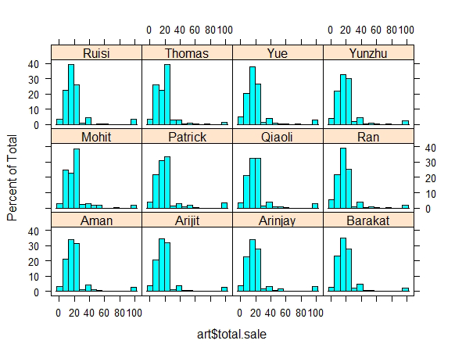

Please note that Adobe Illustrator is not required for completing Homework 6, including the last two questions. Formatting all your plots in R is sufficient.

Combine all plots into a single, multipage PDF file. Turn in the PDF file and your R script with the naming convention NetID_week4.pdf/NetID_week4.R